**AMRITA VISHWA VIDYAPEETHAM**

**AMRITA SCHOOL OF ENGINEERING, COIMBATORE**

**DEPARTMENT OF COMPUTER SCIENCE AND ENGINEERING**

**2020 – 2021 EVEN SEMESTER**

**18CS213 DBMS**

**ONLINE EVENT MANAGEMENT SYSTEM**

**2.Team details:**

|  |  |  |  |
| --- | --- | --- | --- |
| **S.NO** | **ROLL NO** | **NAME** | **ROLE** |
| 1 | CB.SC.I5DAS19011 | ASWIN | INTEGRATING FRONT AND BACK END |
| 2 | CB.SC.I5DAS19023 | NIVEDHA | BACK END |
| 3 | CB.SC.I5DAS19036 | DHANUSHKA SHREE | FRONT END |

**3.Table of contents**

ABSTRACT 3

PREVIEW OF THE PROJECT 4

TABLE CREATION 6

UI DESIGN 9

CONNECTIVITY CODE 12

UI PROJECT CODE 13

CONCLUSION 56

REFERENCES…………………………………………………………………………………………………………………………………….58

**4.Abstract:**

The main goal of this project is to provide interaction between Customer and Owner of particular event organization, to provide better information to the customers within short time. It can be accessed by anyone to book an particular event.This is an easy and accessible way for anyone to book the desired event.

**5.Preview of the project**

1. Introduction:

Today entertainment and event management has become a large income generating market. Many of the industry profiles state that any event which requires funds would call for an excess budget, but the fact is a well-planned strategy for an event will work on any budget. Event management thus becomes a very important part of your event plan.

2. Motivation (need of project):

* + - Project titled Event management System is planned to be designed to locate all the information in single website.
    - The event management System provides better information about any event description and location and all extra info
    - It is not time consuming, so a person can book any events any events they like in comfortable and affordable way

3.Tools used:

* + - MYSQL
    - CSS
    - HTML
    - PHP
    - XAMPP SERVER FOR DATABSE CONNECTIVITY
    - JAVA SCRIPT

**6.Table creation**

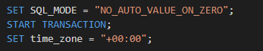

**TABLE “EVENTS"**

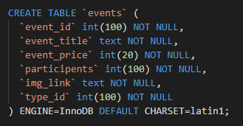

**TABLE “EVENT_TYPE”**

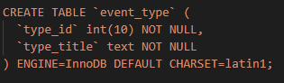

**TABLE “PARTICIPANTS”**

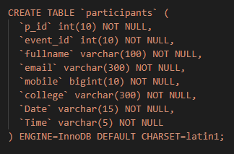

**7.UI design:**

**HOME PAGE**

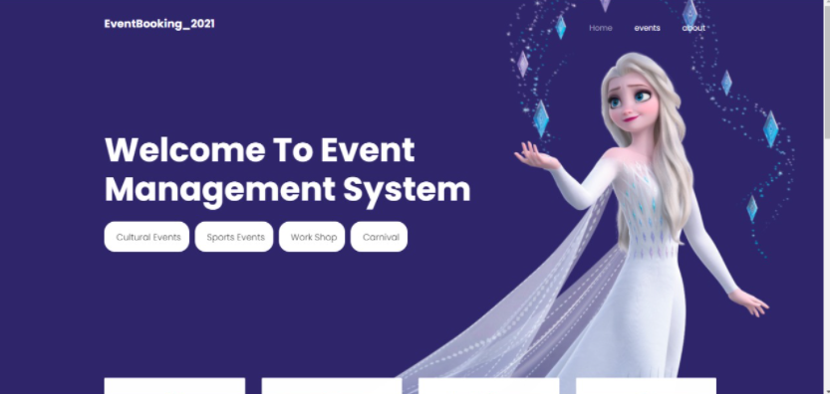

**ABOUT PAGE**

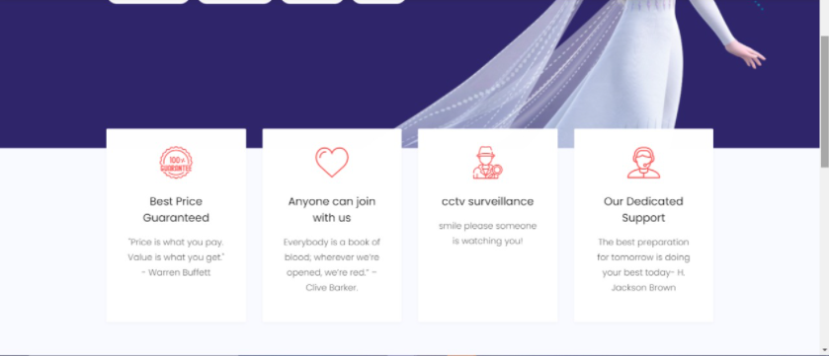

**EVENT POSTERS**

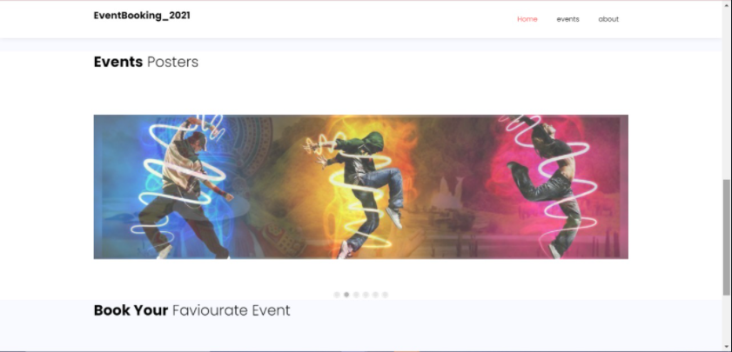

**LIST OF EVENT CATEGORIES TO BOOK**

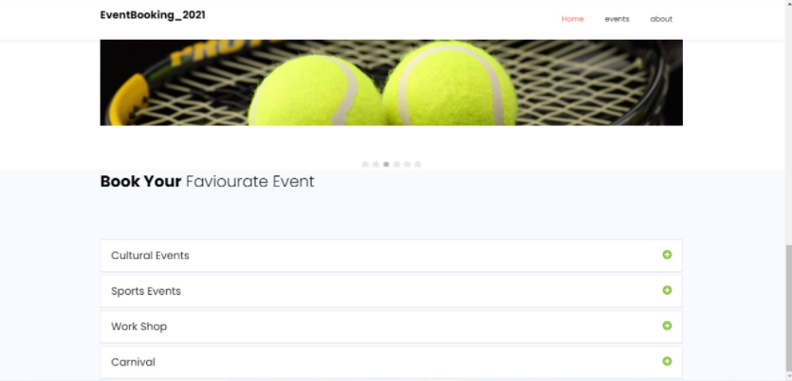

**LIST OF EVENTS IN PARTICULAR CATEGORY**

**(eg: In category cultural events we have 2 events listed i.e, dance and mime,actings etc)**

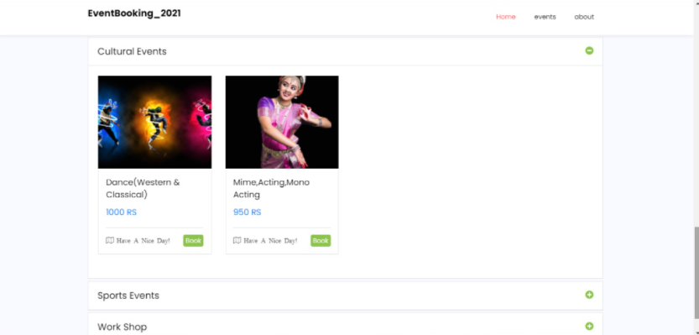

**EVENTS PAGE:**

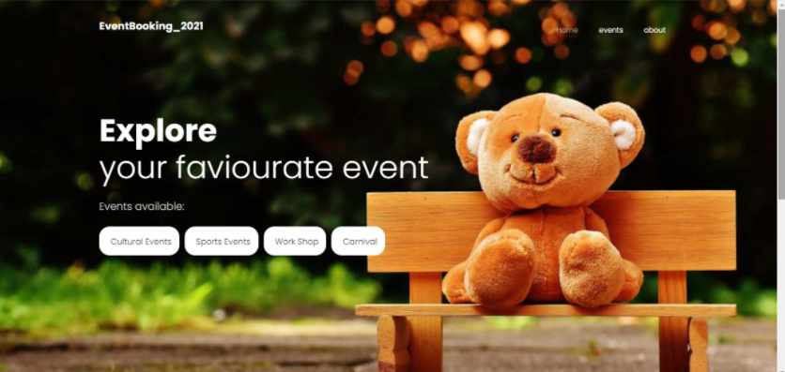

**USER REGISTRATION PAGE:**

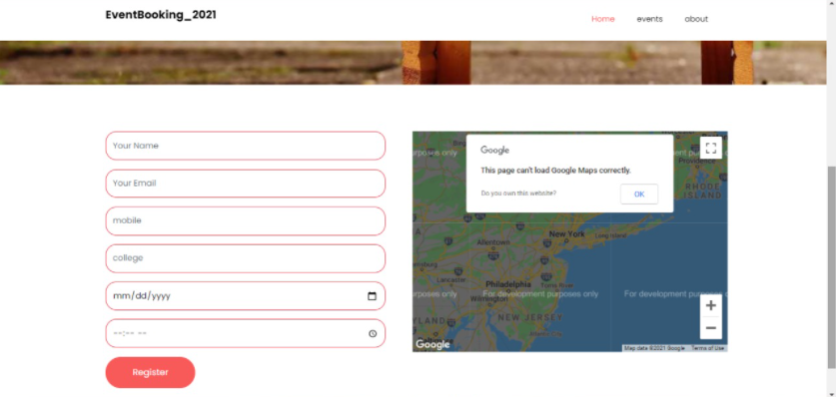

**SUCESSFULLY REGISTERED :**

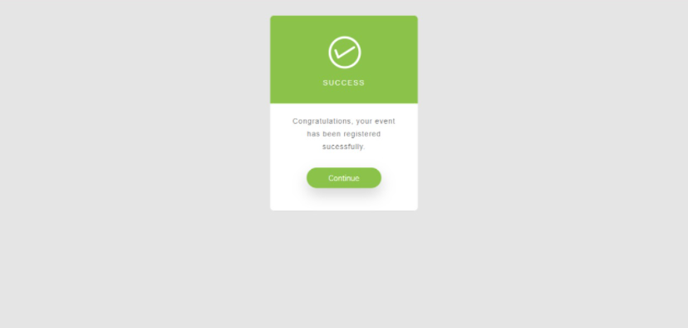

**8. Connectivity Code**

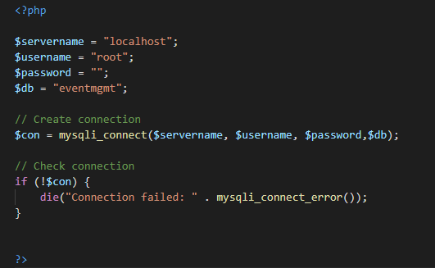

**9. UI PROJECT CODE:**

**Header Code**

<nav class="navbar navbar-expand-lg navbar-dark ftco_navbar bg-dark ftco-navbar-light" id="ftco-navbar">

    <div class="container">

      <a class="navbar-brand" href="index.html"><p>EventBooking_2021</p></a>

      <button class="navbar-toggler" type="button" data-toggle="collapse" data-target="#ftco-nav" aria-controls="ftco-nav" aria-expanded="false" aria-label="Toggle navigation">

        <span class="oi oi-menu"></span> Menu

      </button>

      <div class="collapse navbar-collapse" id="ftco-nav">

        <ul class="navbar-nav ml-auto">

          <li class="nav-item active"><a href="index.php" class="nav-link">Home</a></li>

          <li class="nav-item"><a href="#events" class="nav-link">events</a></li>

          <li class="nav-item"><a href="#about" class="nav-link">about</a></li>

        </ul>

      </div>

    </div>

  </nav>

**Body Code**

<body>

  <?php

  include "header.php";

  ?>

    <!-- END nav -->

    <div class="hero-wrap js-fullheight" style="background-image: url('images/12.jpg');">

      <div class="overlay"></div>

      <div class="container">

        <div class="row no-gutters slider-text js-fullheight align-items-center justify-content-start" data-scrollax-parent="true">

          <div class="col-md-9 ftco-animate" data-scrollax=" properties: { translateY: '70%' }">

            <h1 class="mb-4" data-scrollax="properties: { translateY: '30%', opacity: 1.6 }"><strong>Welcome To Event Management System</strong></h1>

            <div>

            <h1 class="mb-4"  data-scrollax="properties: { translateY: '30%', opacity: 1.6 }"></h1>

            </div>

            <div class="browse d-md-flex col-md-12" >

                <div class="row">

                  <?php

                  $type_query = "SELECT * FROM event_type";

                  $run_query = mysqli_query($con,$type_query);

                  if(mysqli_num_rows($run_query) > 0){

                    $i=0;

                    while($row = mysqli_fetch_array($run_query)){

                      $type_id = $row["type_id"];

                      $type_title = $row["type_title"];

                      $tag_id=$i++;

                      echo "

                      <span class='d-flex justify-content-center align-items-md-center'><a href='#$tag_id' style='border-radius:20px;margin-bottom:20px;'><i class=''></i>$type_title</a></span>

                      ";

                    }

                  }

                  ?>

            </div>

            </div>

          </div>

        </div>

      </div>

    </div>

    <section class="ftco-section services-section bg-light">

      <div class="container">

        <div class="row d-flex">

          <div class="col-md-3 d-flex align-self-stretch ftco-animate">

            <div class="media block-6 services d-block text-center">

              <div class="d-flex justify-content-center"><div class="icon"><span class="flaticon-guarantee"></span></div></div>

              <div class="media-body p-2 mt-2">

                <h3 class="heading mb-3">Best Price Guaranteed</h3>

                <p>"Price is what you pay. Value is what you get." - Warren Buffett</p>

              </div>

            </div>

          </div>

          <div class="col-md-3 d-flex align-self-stretch ftco-animate">

            <div class="media block-6 services d-block text-center">

              <div class="d-flex justify-content-center"><div class="icon"><span class="flaticon-like"></span></div></div>

              <div class="media-body p-2 mt-2">

                <h3 class="heading mb-3">Anyone can join with us</h3>

                <p>Everybody is a book of blood; wherever we’re opened, we’re red.” – Clive Barker.</p>

              </div>

            </div>

          </div>

          <div class="col-md-3 d-flex align-self-stretch ftco-animate">

            <div class="media block-6 services d-block text-center">

              <div class="d-flex justify-content-center"><div class="icon"><span class="flaticon-detective"></span></div></div>

              <div class="media-body p-2 mt-2">

                <h3 class="heading mb-3">cctv surveillance</h3>

                <p>smile please someone is watching you!</p>

              </div>

            </div>

          </div>

          <div class="col-md-3 d-flex align-self-stretch ftco-animate">

            <div class="media block-6 services d-block text-center">

              <div class="d-flex justify-content-center"><div class="icon"><span class="flaticon-support"></span></div></div>

              <div class="media-body p-2 mt-2">

                <h3 class="heading mb-3">Our Dedicated Support</h3>

                <p>The best preparation for tomorrow is doing your best today- H. Jackson Brown</p>

              </div>

            </div>

          </div>

        </div>

      </div>

    </section>

    <section class=" ftco-destination">

      <div class="container">

        <div class="row justify-content-start mb-5 pb-3">

          <div class="col-md-7 heading-section ftco-animate">

            <h2 class="mb-4"><strong>Events</strong> Posters</h2>

          </div>

        </div>

        <div class="row">

          <div class="col-md-12">

            <div class="single-slider owl-carousel ftco-animate">

              <div class="item">

                <div class="destination">

                  <a href="#" class="img d-flex justify-content-center align-items-center" style="background-image: url(images/3.jpg);">

                  </a>

                </div>

              </div>

              <div class="item">

                <div class="destination">

                  <a href="#" class="img d-flex justify-content-center align-items-center" style="background-image: url(images/25.jpg);">

                  </a>

                </div>

              </div>

              <div class="item">

                <div class="destination">

                  <a href="#" class="img d-flex justify-content-center align-items-center" style="background-image: url(images/20.jpg);">

                  </a>

                </div>

              </div>

              <div class="item">

                <div class="destination">

                  <a href="#" class="img d-flex justify-content-center align-items-center" style="background-image: url(images/18.jpg);">

                  </a>

                </div>

              </div>

              <div class="item">

                <div class="destination">

                  <a href="#" class="img d-flex justify-content-center align-items-center" style="background-image: url(images/7.jpg);">

                  </a>

                </div>

              </div>

              <div class="item">

                <div class="destination">

                  <a href="#" class="img d-flex justify-content-center align-items-center" style="background-image: url(images/8.jpg);">

                  </a>

                </div>

              </div>

            </div>

          </div>

        </div>

      </div>

    </section>

    <section class=" bg-light" id="events">

      <div class="container" id="0">

        <div class="row justify-content-start mb-5 pb-3">

             <div class="col-md-7 heading-section ftco-animate">

            <h2 class="mb-4"><strong>Book Your</strong>  Faviourate Event</h2>

          </div>

        </div>

        <div class="row" id="technical" >

          <div class="col-md-12 ftco-animate">

            <div id="accordion">

              <div class="row" >

                <div class="col-md-12">

                  <div id="get_events"></div>

                      <?php

                      $event_query = "SELECT * FROM event_type";

                      $run_query1 = mysqli_query($con,$event_query);

                      if(mysqli_num_rows($run_query1) > 0){

                        while($row = mysqli_fetch_array($run_query1)){

                        $type_id = $row["type_id"];

                        $type_title= $row["type_title"];

                        echo "

                        <div class='card'>

                        <div class='card-header' id='$type_id'>

                               <a class='card-link' data-toggle='collapse'  href='#menu$type_id' aria-expanded='false' aria-controls='menu$type_id'>$type_title<span class='collapsed'><i class='icon-plus-circle'></i></span><span class='expanded'><i class='icon-minus-circle'></i></span></a>

                               </div>

                               <div id='menu$type_id' class='collapse'>

                               <div class='card-body'>

                                 <div class='row'>";

                                 $type_query = "SELECT * FROM events,event_type WHERE events.type_id=event_type.type_id";

                                 $run_query2 = mysqli_query($con,$type_query);

                                 if(mysqli_num_rows($run_query2) > 0){

                                 while($row = mysqli_fetch_array($run_query2)){

                                   $newtype_id    = $row['type_id'];

                                   $event_id   = $row['event_id'];

                                   $event_title = $row['event_title'];

                                   $type_title = $row['type_title'];

                                   $event_price = $row['event_price'];

                                   $img_link = $row['img_link'];

                                   if($newtype_id==$type_id){

                                   echo "

                                   <div class='col-md-6 col-lg-3 ftco-animate'>

                                   <div class='destination'>

                                     <a href='#' class='img img-2 d-flex justify-content-center align-items-center' style='background-image: url(./images/$img_link);'>

                                       <div class='d-flex justify-content-center align-items-center'>

                                       </div>

                                     </a>

                                     <div class='text p-3'>

                                       <h3><a href='#'>$event_title</a></h3>

                                       <p class='price' style='font-weight: 400;font-size: 18px;color: #2f89fc;'>

                                         $event_price

                                         <span>RS</span>

                                       </p>

                                       <hr>

                                       <p class='bottom-area d-flex'>

                                         <span><i class='icon-map-o'>  Have A Nice Day!</i></span>

                                         <span class='ml-auto'><a href='register.php?event_id=$event_id'>Book</a></span>

                                       </p>

                                     </div>

                                   </div>

                                 </div>";

                                   }

                                 }

                                 }

                              echo"

                              </div>

                               </div>

                             </div>

                             </div>

                             ";

                        }

                      }

                      ?>

                  </div>

              </div>

            </div>

          </div>

        </div>

      </div>

    </section>

**Footer Code**

<style>

/* Button used to open the chat form - fixed at the bottom of the page */

.float{

  position:fixed;

  width:60px;

  height:60px;

  bottom:40px;

  right:40px;

  font-size:25px;

  background-color:cyan;

  color:#FFF;

  border-radius:50px;

  text-align:center;

  box-shadow: 2px 2px 3px #999;

}

.my-float{

  margin-top:22px;

}

/* The popup chat - hidden by default */

.chat-popup {

  display: none;

  position: fixed;

  bottom: 0;

  right: 15px;

  border: 3px solid #f1f1f1;

  z-index: 9;

}

/* Add styles to the form container */

.form-container {

  max-width: 300px;

  padding: 10px;

  background-color: white;

}

/* Full-width textarea */

.form-container textarea {

  width: 100%;

  padding: 15px;

  margin: 5px 0 22px 0;

  border: none;

  background: #f1f1f1;

  resize: none;

  min-height: 200px;

}

/* When the textarea gets focus, do something */

.form-container textarea:focus {

  background-color: #ddd;

  outline: none;

}

/* Set a style for the submit/send button */

.form-container .btnn {

  background-color: #4CAF50;

  color: green;

  padding: 16px 20px;

  border: none;

  cursor: pointer;

  width: 100%;

  margin-bottom:10px;

  opacity: 0.8;

}

/* Add a red background color to the cancel button */

.form-container .cancel {

  background-color: red;

}

/* Add some hover effects to buttons */

.form-container .btnn:hover, .open-button:hover {

  opacity: 1;

}

</style>

**Register Code**

<?php

session_start();

$ip_add = getenv("REMOTE_ADDR");

include "db/connect.php";

?>

<!DOCTYPE html>

<html lang="en">

<?php

include "cssjs/css.php";

?>

<body>

  <?php

  include "includes/header.php";

  ?>

  <style>

  .field-border{

    border-radius:20px;

  }

  </style>

  <div class="hero-wrap js-fullheight" style="background-image: url('images/2.jpg');">

      <div class="overlay"></div>

      <div class="container">

        <div class="row no-gutters slider-text js-fullheight align-items-center justify-content-start" data-scrollax-parent="true">

          <div class="col-md-9 ftco-animate" data-scrollax=" properties: { translateY: '70%' }">

            <h1 class="mb-4" data-scrollax="properties: { translateY: '30%', opacity: 1.6 }"><strong>Explore <br></strong> your faviourate event</h1>

            <p data-scrollax="properties: { translateY: '30%', opacity: 1.6 }">Events available:</p>

            <div>

            <h1 class="mb-4"  data-scrollax="properties: { translateY: '30%', opacity: 1.6 }"></h1>

            </div>

            <div class="browse d-md-flex col-md-12" >

                <div class="row">

                  <?php

                  $type_query = "SELECT * FROM event_type";

                  $run_query = mysqli_query($con,$type_query);

                  if(mysqli_num_rows($run_query) > 0){

                    $i=0;

                    while($row = mysqli_fetch_array($run_query)){

                      $type_id = $row["type_id"];

                      $type_title = $row["type_title"];

                      $tag_id=$i++;

                      echo "

                      <span class='d-flex justify-content-center align-items-md-center'><a href='#$tag_id' style='border-radius:20px;margin-bottom:20px;'><i class=''></i>$type_title</a></span>

                      ";

                    }

                  }

                  ?>

            </div>

            </div>

          </div>

        </div>

      </div>

    </div>

<section class="ftco-section contact-section ftco-degree-bg">

      <div class="container">

      <div class="col-md-8" id="signup_msg">

         <!--Alert from signup form-->

       </div>

        <div class="row block-9">

          <div class="col-md-6 pr-md-5">

            <form id="signup_form" onsubmit="return false" class="was-validated">

              <div class="form-group" >

                <input type="text" name="full_name" class="form-control field-border" placeholder="Your Name"  required>

              </div>

              <?php

                if ($_GET['event_id'] != ''){

                  $event_id = $_GET['event_id'];

                  echo '<input type="hidden" name="event_id" value='.$event_id.' class="form-control field-border"   required>';

                }

              ?>

              <div class="form-group">

                <input type="email" name="email" class="form-control field-border" placeholder="Your Email" required>

              </div>

              <div class="form-group">

                <input type="text" class="form-control field-border" name="mobile" placeholder="mobile" required>

              </div>

              <div class="form-group">

                <input type="text" class="form-control field-border" name="college" placeholder="college" required>

              </div>

              <div class="form-group">

                <input type="date" class="form-control field-border" name="Date" placeholder="Date" required>

              </div>

              <div class="form-group">

                <input type="time" class="form-control field-border" name="time" placeholder="time" required>

              </div>

              <div class="form-group">

                <input value="Register" type="submit" name="signup_button" class="btn btn-primary py-3 px-5 "  required>

              </div>

            </form>

          </div>

          <div class="col-md-6" id="map"></div>

        </div>

      </div>

    </section>

<?php

include "includes/footer.php";

?>

  <!-- loader -->

  <div id="ftco-loader" class="show fullscreen"><svg class="circular" width="48px" height="48px"><circle class="path-bg" cx="24" cy="24" r="22" fill="none" stroke-width="4" stroke="#eeeeee"/><circle class="path" cx="24" cy="24" r="22" fill="none" stroke-width="4" stroke-miterlimit="10" stroke="#F96D00"/></svg></div>

  <?php

  include "cssjs/js.php";

  ?>

  <script>

  </script>

  </body>

</html>

**Successfully Registered Page Code**

<!DOCTYPE html>

<html lang="en">

<head>

    <meta charset="UTF-8" />

    <meta http-equiv="X-UA-Compatible" content="IE=edge,chrome=1">

    <meta name="viewport" content="width=device-width, initial-scale=1.0">

    <meta name="author" content="Codeconvey" />

    <!-- Message Box CSS -->

    <link rel="stylesheet" href="css1/style.css">

    <!--Only for demo purpose - no need to add.-->

    <link rel="stylesheet" href="css1/demo.css" />

</head>

<body>

<section>

    <div class="rt-container">

          <div class="col-rt-12">

              <div class="Scriptcontent">

<!-- partial:index.partial.html -->

<div id='card' class="animated fadeIn">

  <div id='upper-side'>

    <?xml version="1.0" encoding="utf-8"?>

      <!-- Generator: Adobe Illustrator 17.1.0, SVG Export Plug-In . SVG Version: 6.00 Build 0)  -->

      <!DOCTYPE svg PUBLIC "-//W3C//DTD SVG 1.1//EN" "http://www.w3.org/Graphics/SVG/1.1/DTD/svg11.dtd">

      <svg version="1.1" id="checkmark" xmlns="http://www.w3.org/2000/svg" xmlns:xlink="http://www.w3.org/1999/xlink" x="0px" y="0px" xml:space="preserve">

        <path d="M131.583,92.152l-0.026-0.041c-0.713-1.118-2.197-1.447-3.316-0.734l-31.782,20.257l-4.74-12.65

  c-0.483-1.29-1.882-1.958-3.124-1.493l-0.045,0.017c-1.242,0.465-1.857,1.888-1.374,3.178l5.763,15.382

  c0.131,0.351,0.334,0.65,0.579,0.898c0.028,0.029,0.06,0.052,0.089,0.08c0.08,0.073,0.159,0.147,0.246,0.209

  c0.071,0.051,0.147,0.091,0.222,0.133c0.058,0.033,0.115,0.069,0.175,0.097c0.081,0.037,0.165,0.063,0.249,0.091

  c0.065,0.022,0.128,0.047,0.195,0.063c0.079,0.019,0.159,0.026,0.239,0.037c0.074,0.01,0.147,0.024,0.221,0.027

  c0.097,0.004,0.194-0.006,0.292-0.014c0.055-0.005,0.109-0.003,0.163-0.012c0.323-0.048,0.641-0.16,0.933-0.346l34.305-21.865

  C131.967,94.755,132.296,93.271,131.583,92.152z" />

        <circle fill="none" stroke="#ffffff" stroke-width="5" stroke-miterlimit="10" cx="109.486" cy="104.353" r="32.53" />

      </svg>

      <h3 id='status'>

      Success

    </h3>

  </div>

  <div id='lower-side'>

    <p id='message'>

      Congratulations, your event has been registered sucessfully.

    </p>

    <a href="index.php" id="contBtn">Continue</a>

  </div>

</div>

<!-- partial -->

        </div>

    </div>

    </div>

</section>

    <!-- Analytics -->

  </body>

</html>

**10.Conclusion:**

Our website you will have 3 options which are HOME , ABOUT , EVENT .

HOME: welcome to event management system sign in big letters along with types of events designed below it. As you scroll down, you can read the moto of our website. After scrolling more you can see an event poster slide show of types of event which is easy for user to see what kinds of events available through posters itself. As you scroll more you can see variety of events to book.

EVENT: clicking the event will take you directly to the event booking part of the home page, where there will be options for you to book the types of events. so, once you click book sign, there you wi1l have variety of categories under each event type and once you click a category, it will ask you to book an event where it will take you to register page:

REGISTER: This will ask for name , email , phone number , college , date and time of booking an event and once you enter all this you will have an message that “CONGRATULATION ! YOUR EVENT HAS BEEN REGISTERED SUCCESSFULLY “which indicates that your event has been booked and updated to the participants table.

This is what our webpage does where it gives easy interface for users to book any event they want.

**References:**

<https://www.w3schools.com/html/html_css.asp>

<https://github.com/vishnuvardhan-maliki/Event-Management-System-master>

<https://www.semnox.com/?utm_medium=adwords&utm_campaign=&utm_source=&utm_content=&utm_term=online%20event%20booking%20system&gclid=CjwKCAjw7diEBhB-EiwAskVi12Q28iG6Jg95XQyc4DYB0K8slO_oEytt1t6rUVb9IhUxgu4qHm2TMxoC3YMQAvD_BwE>